CS 3050 Homework #6 Colin Fuemmeler cjffqw

**Problem #1**

Insert node u with edges v into tree

Similar to Prim’s Algorithm:  
key[u] = ∞;  
p[u] = null;  
key[r] = 0;  
for each v ∈ Adj[u]  
if (v ∈ Q and w(u,v) < key[v])  
p[v] = u;  
ChangeKey(v, w(u,v));

**Problem #2**

Step 1: explore smallest edge of 2 and connect to tree

Step 2: explore 8 over 20 and connect

Step 3: 12 < 30, explore and move to 5

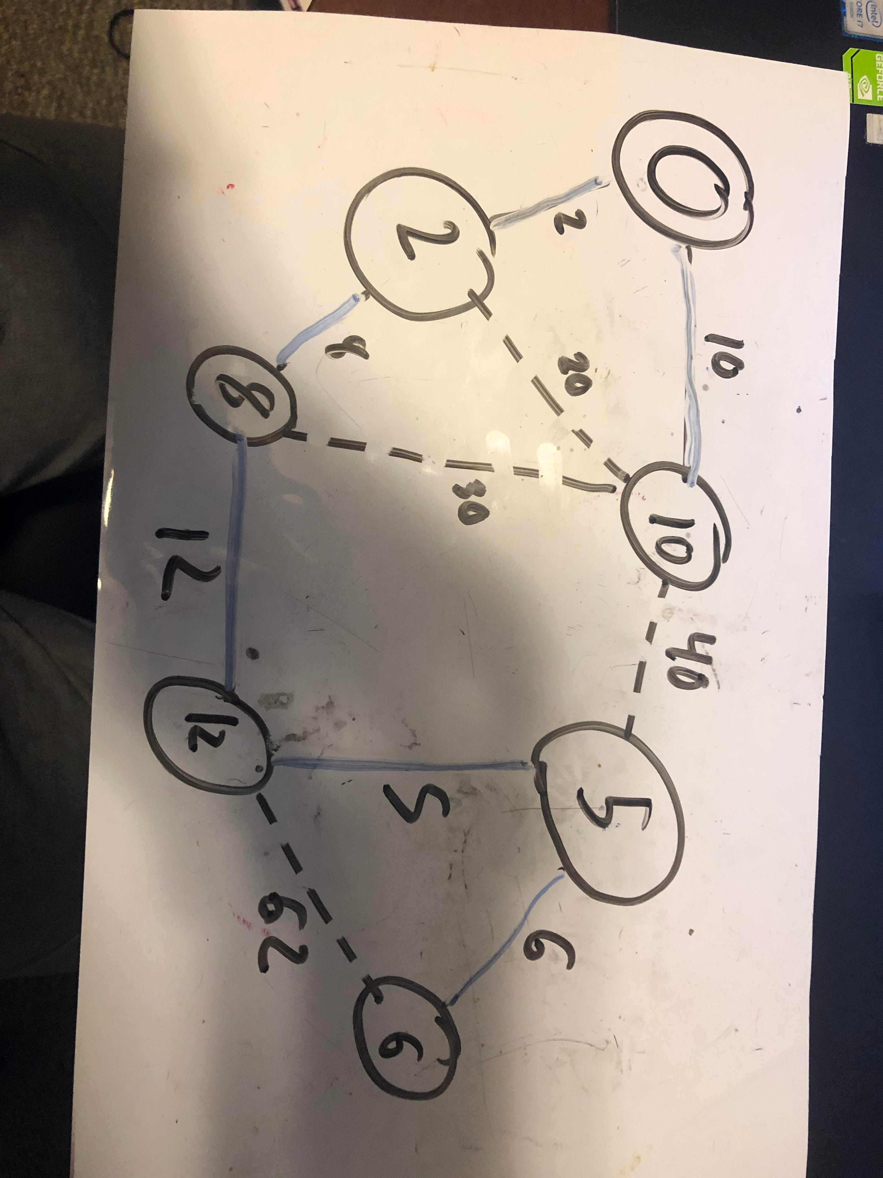

**Problem #3**

With edge weights being integers in the range 1 to |V|, we can use Counting-Sort to sort the edges in O(V+ E) time. Then the algorithm will run in O(V+ E+ Vlog V) = O(E+ Vlog V)  
time.  
If the weights are integers from 1 to W for some constant W, we can sort the edges in O(W+ E) time and Kruskal's algorithm will run in O(W+ E+ Vlog V) time.

**Problem #4**

This problem is simply handled by Kruskal’s Algorithm. By sorting by edge weight, we can accurately and efficiently locate the largest unnecessary edge to remove in order to make our Minimum Spanning Tree.

sort all edges according to weights  
T = {}. tree(v) = v for all v.  
for each edge (u, v)  
if tree(u) != tree(v)  
T = T U (u, v);  
union (tree(u), tree(v))

**Problem #5**

Minimum Bottleneck Spanning Tree (modified from Wikipedia’s pseudocode)

MBST(graph G, weights w)

E = edges of G

If E > 1:

A = (e ∈ E and e > median weight)

B = E – A

F = forest(G_B)

If F is spanning tree:

Return(MBST(G_B, w))

Else:

Return(MBST(G_A, w))